Title: Modern sports scrapbook
Name:
Course name:
Course code:
Professor:
Date:

Autumn Sports
The Washington herald. (Washington D.C.) 12th September. 1915
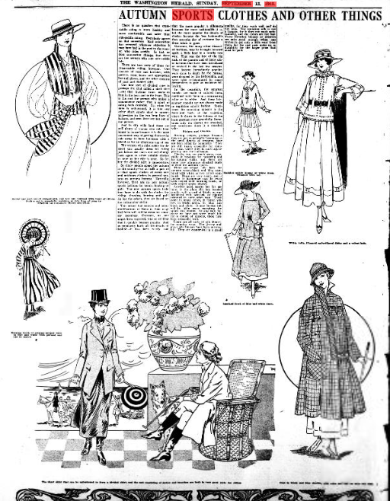

Commentary
The characters in this image symbolize the Autumn Sports Clothes that people wore. Wearing a Jacket and sash net of striped silk, and felt hat was the norm then plus a timmed trith band of ribbon. Such a set was highly welcome at this time of year for sporting activities such as hunting, golf, horse riding and shooting. The significance of this sporting activity was to bring people together to break the winter and have a great time together.

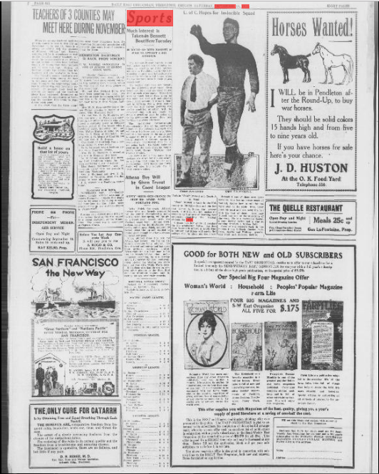
September 18th, 1915- , The Ogden Standard

Commentary
In this event, teachers met at the gymnasium where they trained with a number of friends. Mr and Mrs. Watson were working out every day for the championship title. This was made for the boxing fans. This event brought the teachers together and it was capitalized by the championship title.
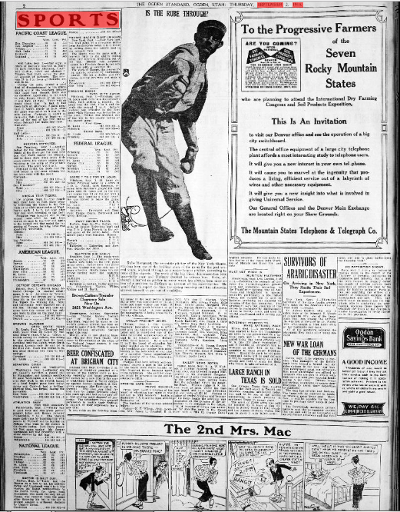
September 02, 1915, The Ogden Standard

Commentary
This sporting event (Pacific Coast League) happened at Utah. Fantastic baseball player and fans congregated at Majertic park where the sporting activity was held. In this event the Beavers were defeated by the local boys- Seals. Other matches were Detroit vs Chicago won by Detroit; Angels vs Tigers won by Angels. The competition brought people from all walks of life whom participated in the event.

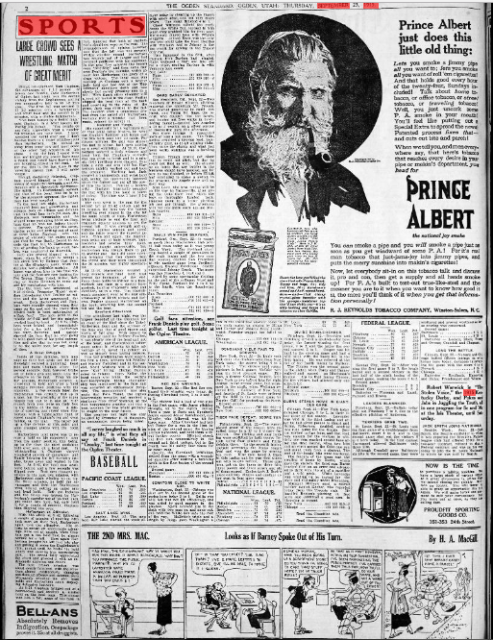
The Ogden standard., September 23, 1915, 4 P.M. CITY EDITION, Page 2,

Commentary
Wrestling match was held this day attended by a large crowd. This sporting event attracted even the golf funs as well. The sporting event was climaxed by the win f Red Sox team defeating the Cleveland twice. The teams which won joined other sin the nationals for the next competition which was held later. This event saw a number of contracts between players and the Federal signed.

The Brattleboro daily reformer., September 18, 1915,
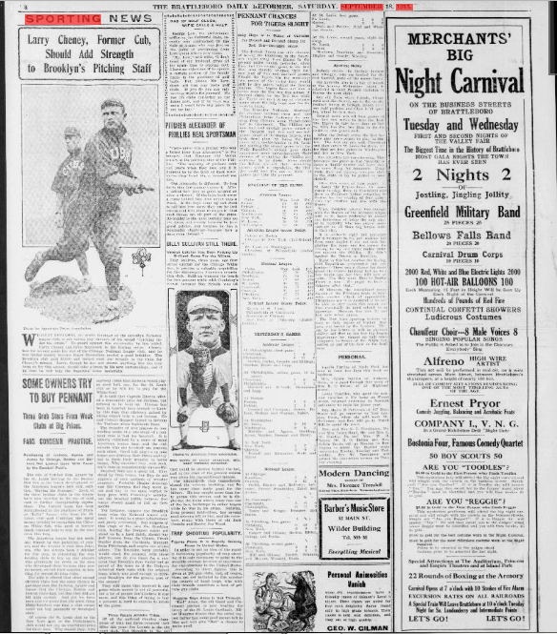Commentary
This was a pitching event and golfing as well. The Detroit Timers saw their chances of taking the leadership in the American .league away from Boston in the present series vanish yesterday, when they lost the second game to the lied Sox, who thereby resumed their former load of two and one-half games. The transfer of star players to trending teams at a late stage of a pennant race, which was bad for baseball.
Honolulu star-bulletin., October 14, 1915, 2:30 Edition, SHIPPING SECTION, Page TEN, Image 10
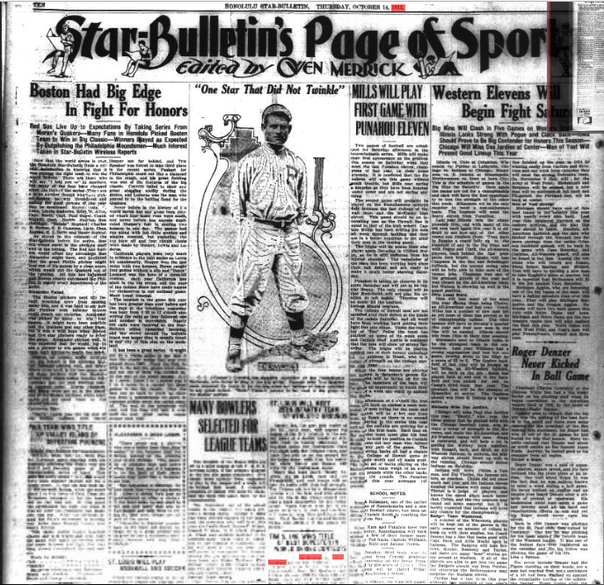
Commentary
This was a big pitching event. Several big time players then participated in the event. California players, were very much in evidence in the past series as Lewis hit consistently. Hooper won the last game with two homers. Burns caught four games without a slip and Dutch Leonard was the hero of a three-hit contexts of the year California . The national games event brought players together to complete.

The Brattleboro daily reformer., September 28, 1915, Page 4,
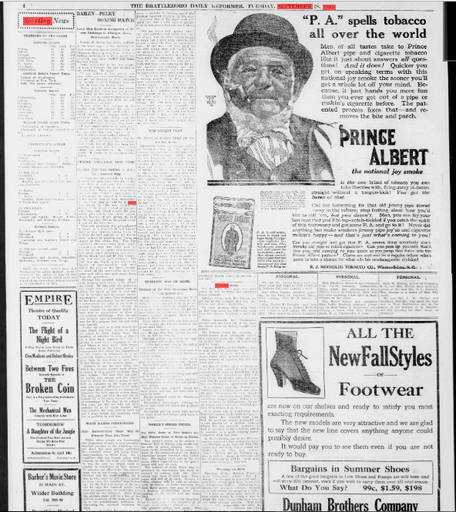
Commentary
This sporting event had only two games scheduled for the national league in that day. The teams were Hiladelphia and Brooklyn.

The Brattleboro daily reformer., September 22, 1915,
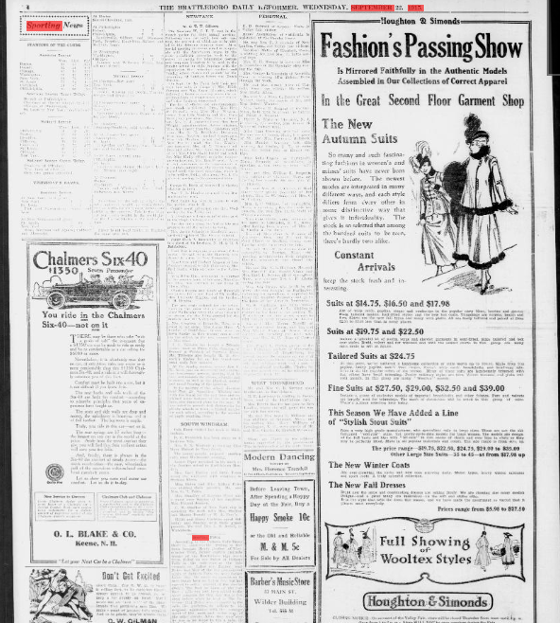
Commentary
On this day, the news reported some sports annual meeting. The Newfane W. C. T. U. met in the parlor for their annual meeting. “Following this the sixth food sale was
held, the proceeds of which are to be added to the drinking fountain fund. At a
special meeting the union voted' to co-operate with the Anti-Saloon league in the
state prohibition campaign work to the extent of paying for temperance posters and campaign.
The Brattleboro daily reformer., September 02, 1915,
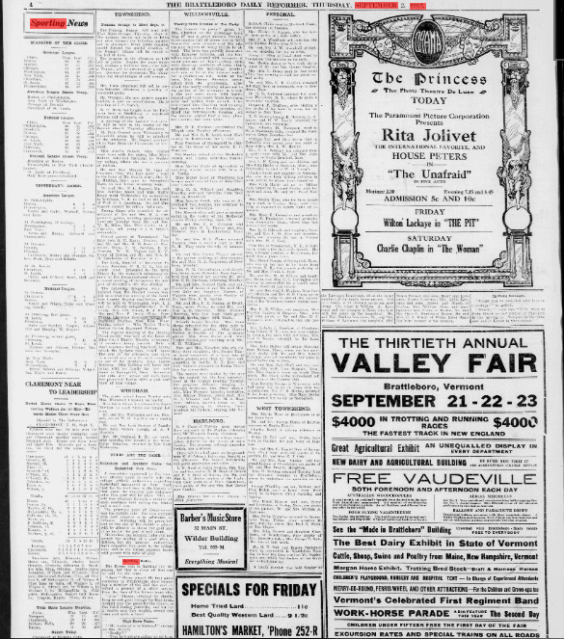
Commentary
This was the sporting news and the standings of the American League. The American league games played that day were also in the paper with Huston playing at Philadelphia and Pliicno at Detroit.

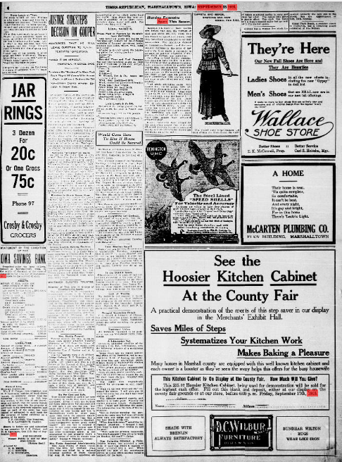
Evening times-Republican. (Marshalltown, Iowa) 1890-1923, September 15, 1915, Image 6

Commentary
This was about the hunting game. Hunters had to take careful
aim before they pull their triggers on shotgun shells this fall, unless they were willing to spend more money than they have been accustomed to on their ammunition. This was as a result of the enormous demand on ammunition factories, and the consequent increase in the price of raw materials. According to local dealers ammunition factories were selling ammunitions to the nations at war in Europe and little of the products were available locally.

New-York tribune. (New York [N.Y.]) 1866-1924, September 26, 1915, SPORTING SECTION, Image 13
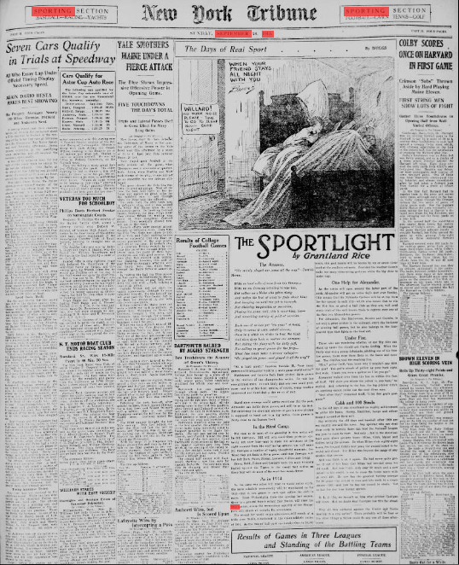
Commentary
These were news on car racing, baseball, yachting and tennis. This was an event meant for entertainment of the city residents and awarding of the winners.

The Brattleboro daily reformer., September 01, 1915, Page 4, Image 4
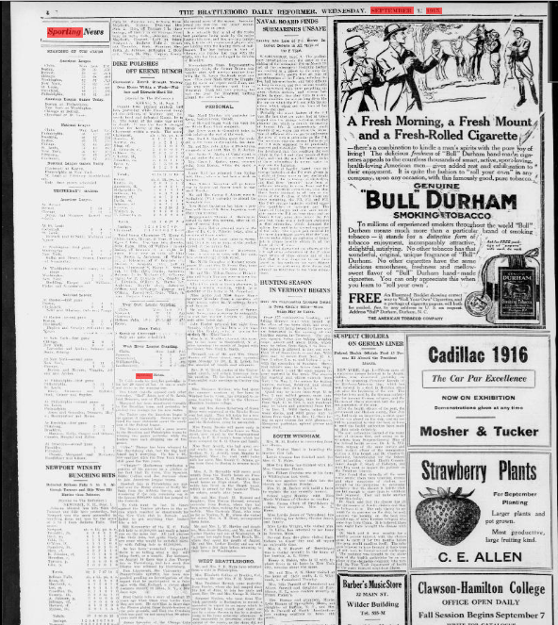
Commentary
This was news about the American League. This included major player contracts and purchases. The event was significant for the teams to choose who would play for them in the following season.

The evening world., September 11, 1913, Final Edition-Baseball and Racing, Page 14, Image 14
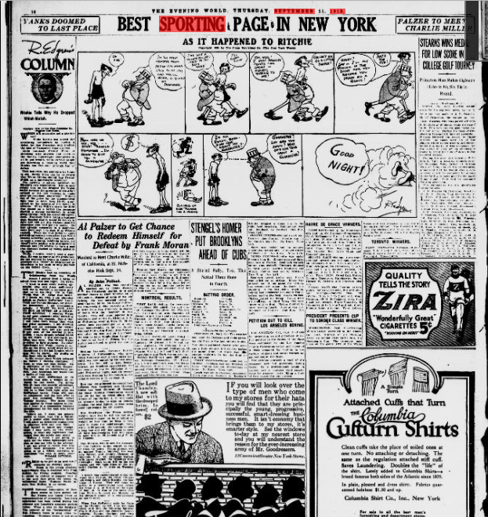
Commentary
This newspaper highlighted the action that was going on in Racing and baseball. It was a significant event for both games to determine the league winners

Reference
https://chroniclingamerica.loc.gov

